**Steps to turn on or off network discovery in Windows 10:**

**Step 1**: Type **network** in the search box and choose **Network and Sharing Center** in the list to open it.

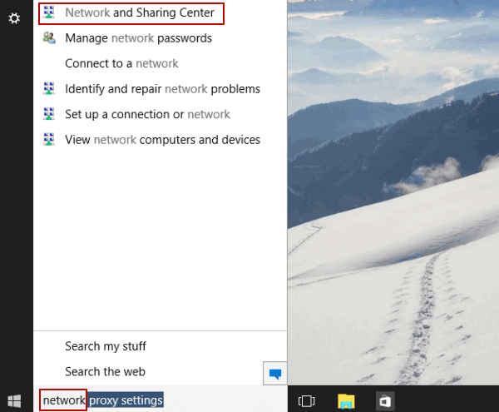

**Step 2**: Select **Change advanced sharing settings** to move on.

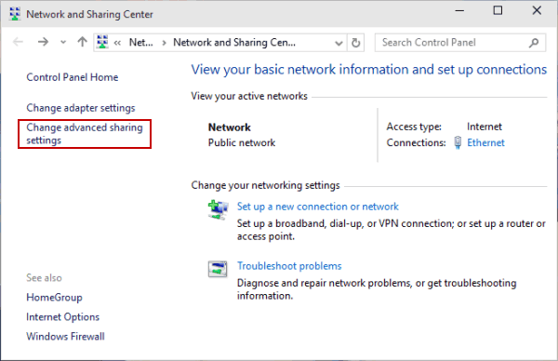

**Step 3**: Choose **Turn on network discovery** or **Turn off network discovery** in the settings, and tap **Save changes**.

